REAL LIFE AND DISTANCE – TIME GRAPHS
Pearson Edexcel - Thursday 7 June 2018 - Paper 2 (Calculator) Higher Tier
1.
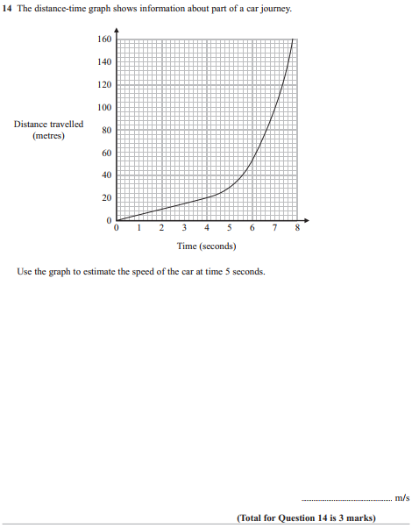

Pearson Edexcel - Monday 6 November 2017 - Paper 2 (Calculator) Higher Tier
2.
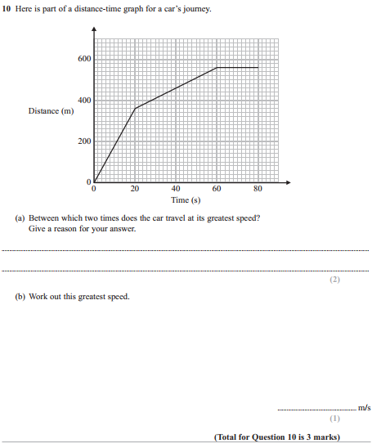

Pearson Edexcel - Sample Paper 1 - (Non-Calculator) Higher Tier
3.
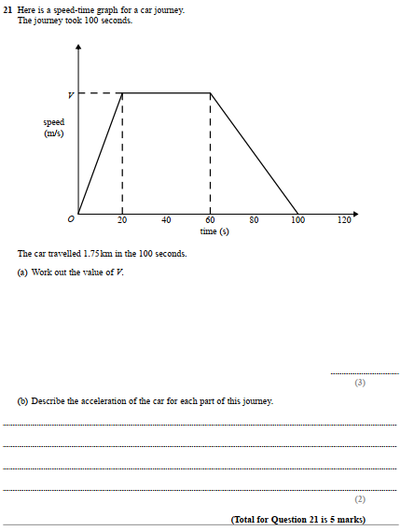

Pearson Edexcel - Monday 4 March 2013 - Paper 2 (Calculator) Higher Tier
4.

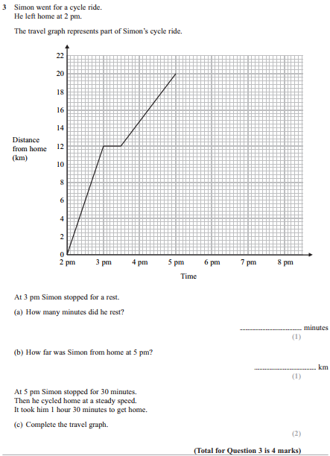

Pearson Edexcel - Monday 7 June 2010 - Paper 3 (Non-Calculator) Higher Tier
5.
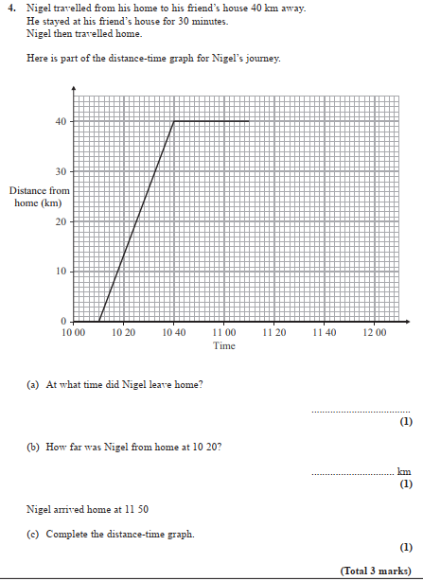
OCR GSCE – Tuesday 3 November 2020 – Paper 4 (Calculator) Higher Tier
6.
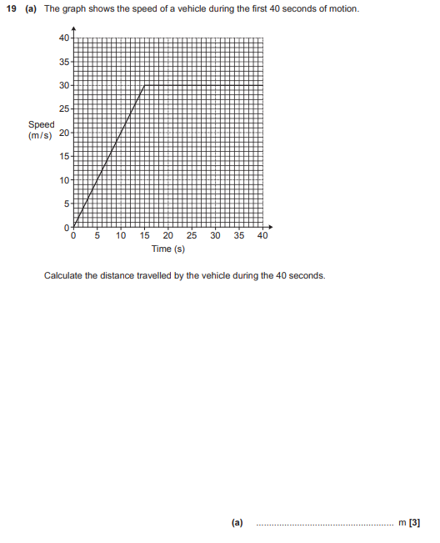
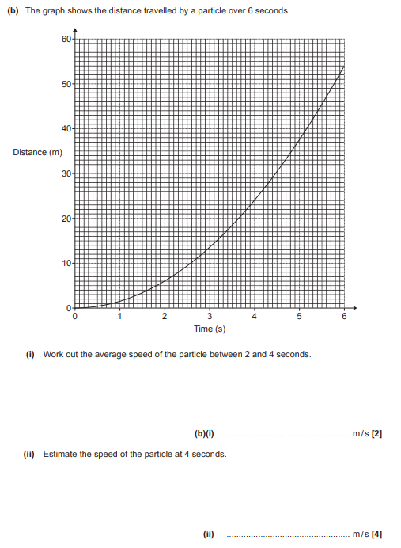

OCR GSCE – Monday 9 November 2020 – Paper 6 (Calculator) Higher Tier
7.
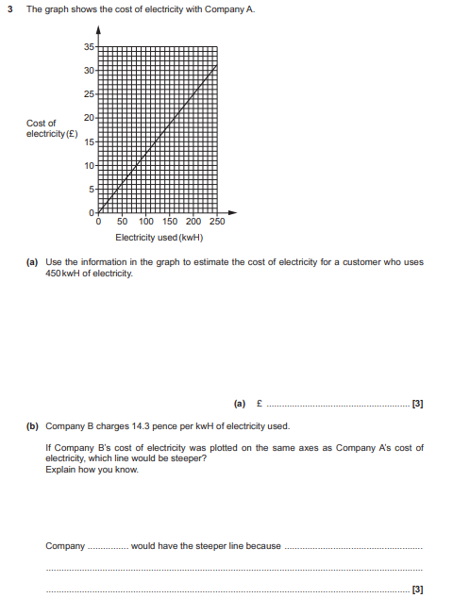

OCR GSCE – Tuesday 5 November 2019 – Paper 6 (Calculator) Higher Tier
8.
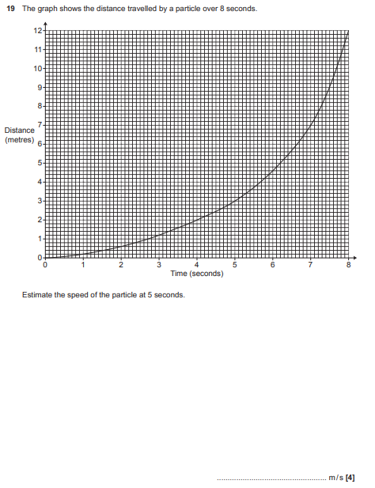

OCR GSCE – Tuesday 21 May 2019 – Paper 4 (Calculator) Higher Tier
9.
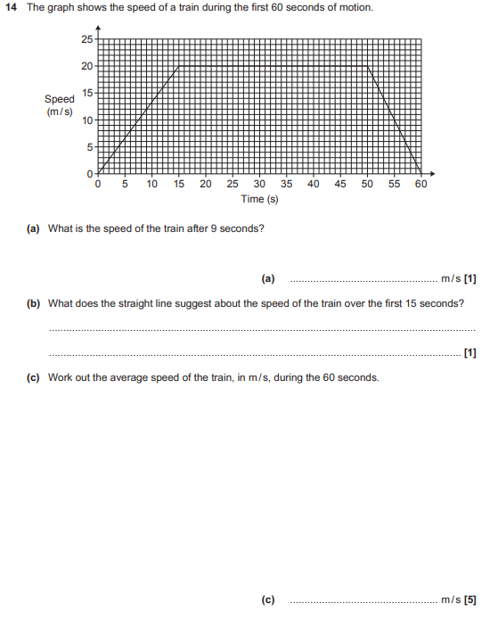

OCR GSCE – Monday 12 November 2018 – Paper 6 (Calculator) Higher Tier
10.
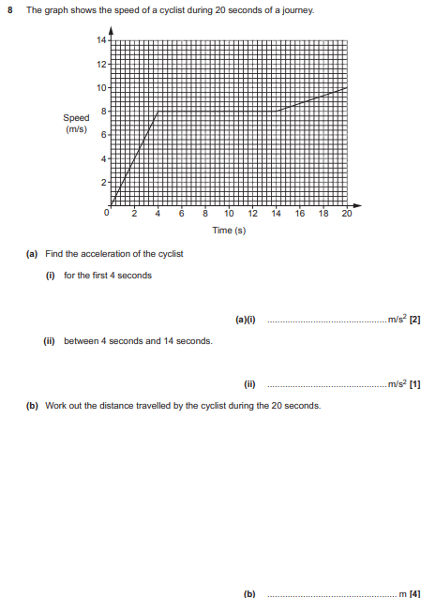

OCR GSCE – Tuesday 12 June 2018 – Paper 6 (Calculator) Higher Tier
11.
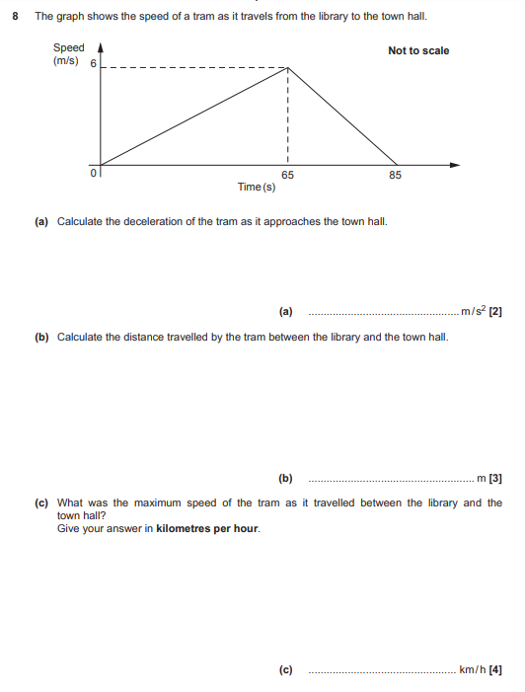

OCR GSCE – Tuesday 6 November 2017 – Paper 5 (Non - Calculator) Higher Tier
12.
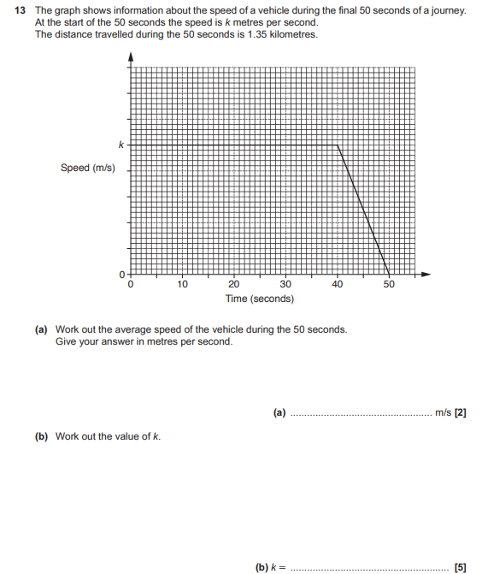

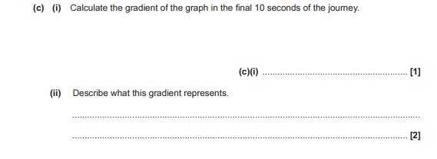
OCR GSCE – Thursday 25 May 2017 – Paper 4 (Calculator) Higher Tier
13.
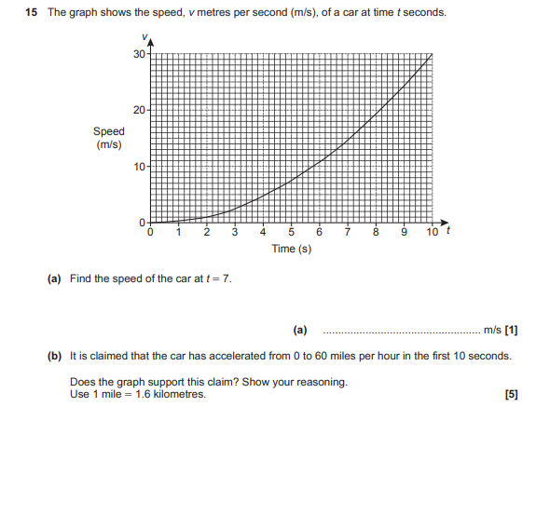
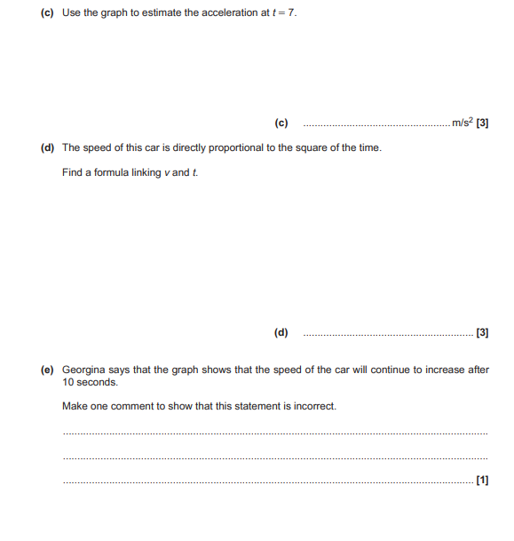

OCR GSCE – Thursday 25 May 2017 – Paper 4 (Calculator) Higher Tier
14.
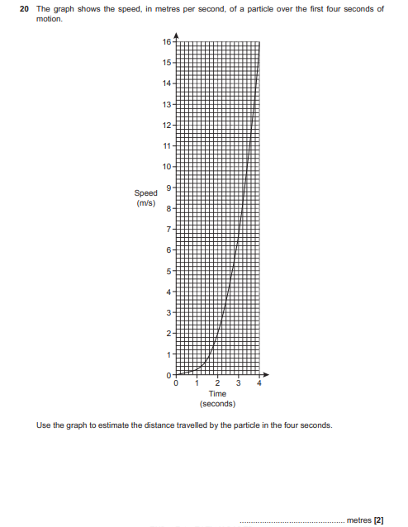

OCR GSCE – Thursday 8 June 2017 – Paper 5 (Non - Calculator) Higher Tier
15.
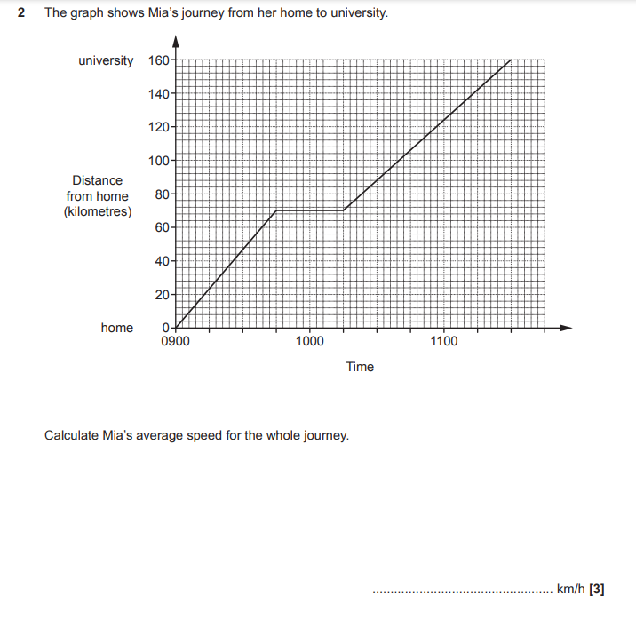

OCR GSCE – Sample Papers – Paper 5 (Non - Calculator) Higher Tier
16.
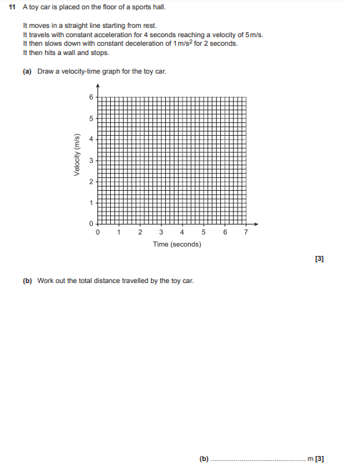

OCR GSCE – Sample Papers – Paper 6 (Calculator) Higher Tier
17.
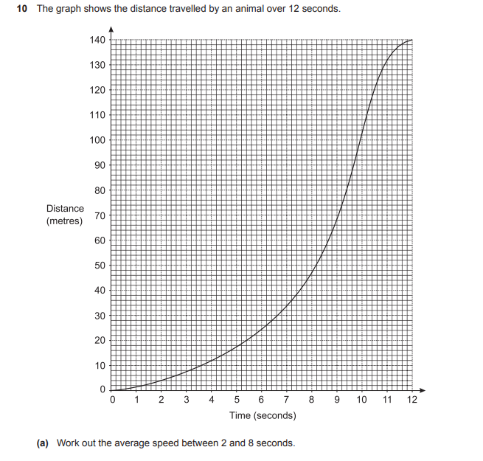
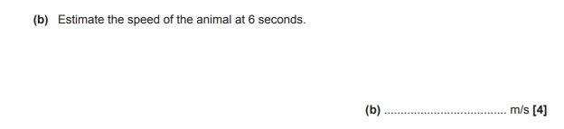
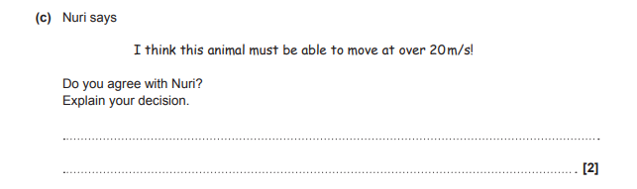
AQA GSCE – Thursday 4 June 2020 – Paper 2 (Calculator) Higher Tier
18.
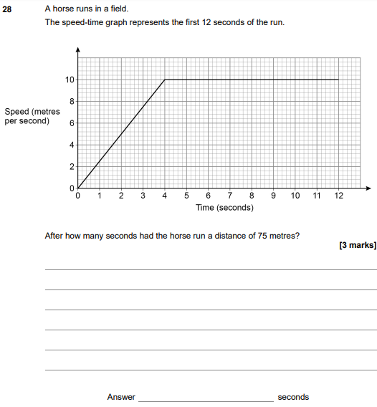
AQA GSCE – Thursday 8 June 2020 – Paper 3 (Calculator) Higher Tier
19.
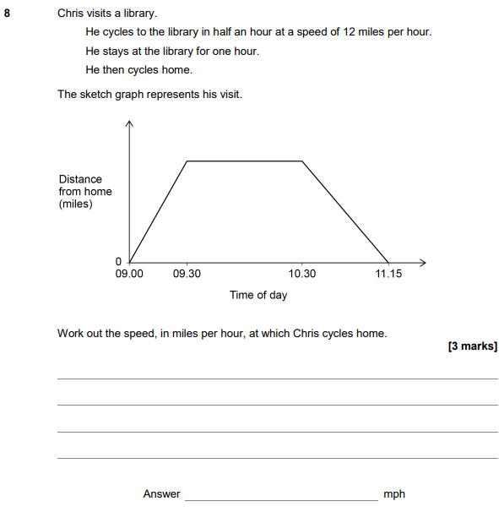

AQA GSCE – Tuesday 11 June 2019 – Paper 3 (Calculator) Higher Tier
20.
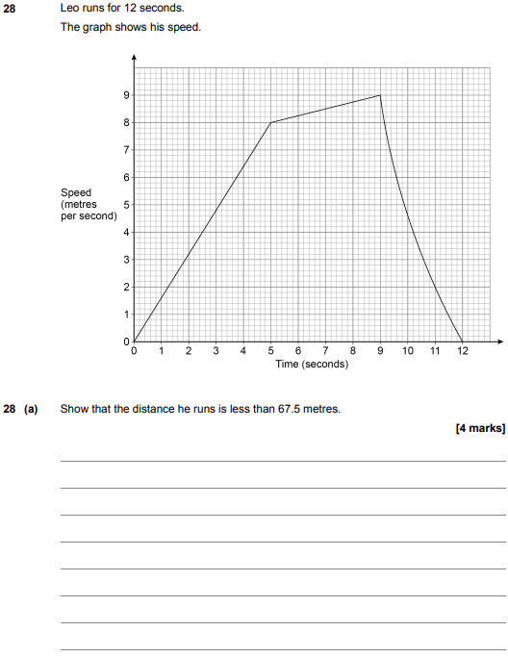
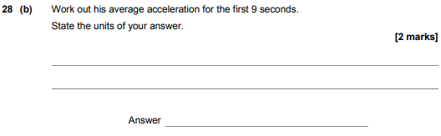

AQA GSCE – Tuesday 6 November 2018 – Paper 1 (Non - Calculator) Higher Tier
21.
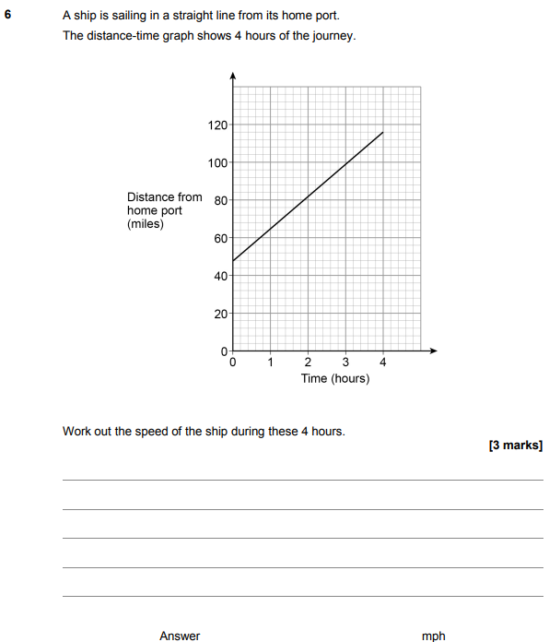

AQA GSCE – Thursday 8 November 2018 – Paper 2 (Calculator) Higher Tier
22.
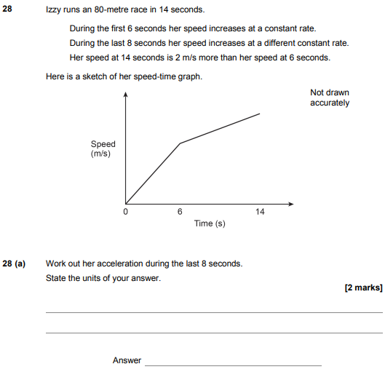
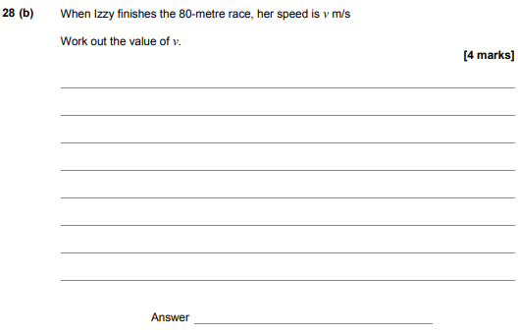

AQA GSCE – Thursday 7 June 2018 – Paper 2 (Calculator) Higher Tier
23.
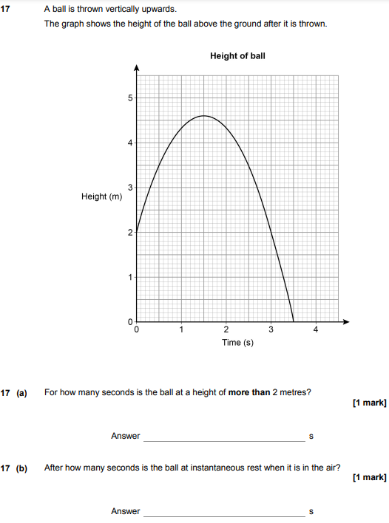
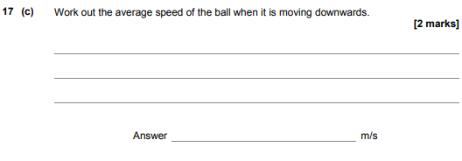
AQA GSCE – Tuesday 12 June 2018 – Paper 3 (Calculator) Higher Tier
24.
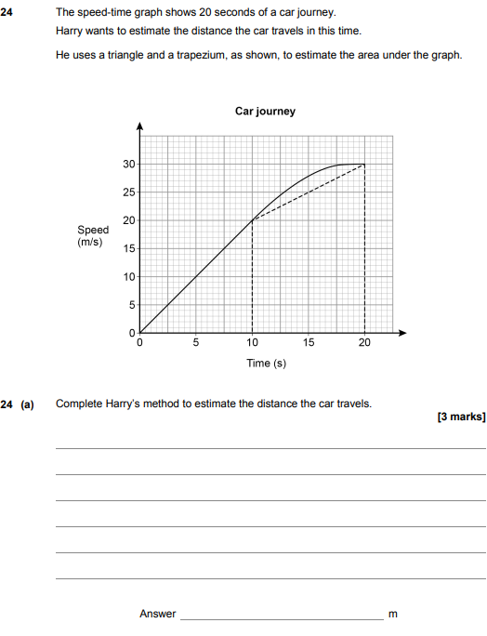
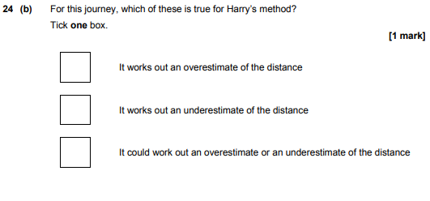
AQA GSCE – Thursday 2 November 2017 – Paper 1 (Non - Calculator) Higher Tier
25.
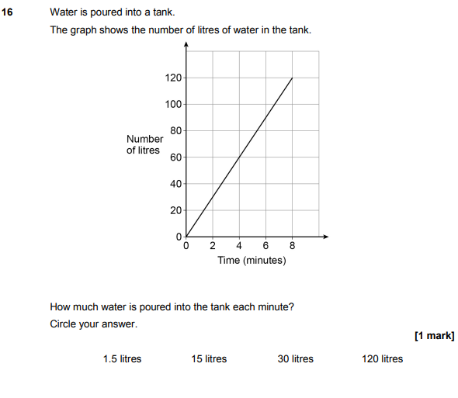
AQA GSCE – Thursday 6 November 2017 – Paper 2 (Calculator) Higher Tier
26.
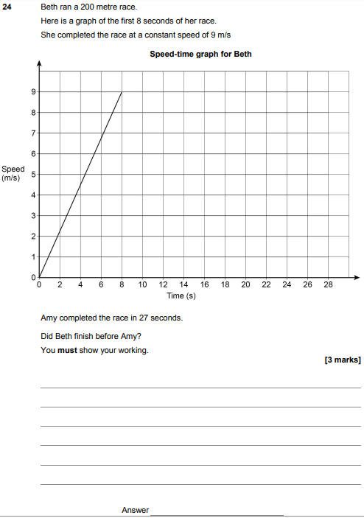

AQA GSCE – Wednesday 8 November 2017 – Paper 3 (Calculator) Higher Tier
27.
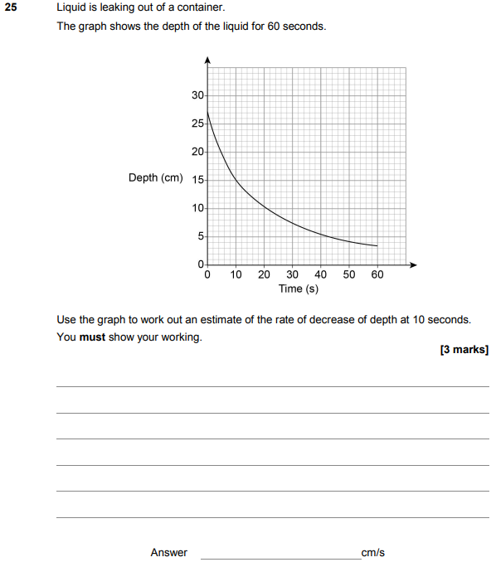

AQA GSCE – Wednesday 25 May 2017 – Paper 1 (Non - Calculator) Higher Tier
28.
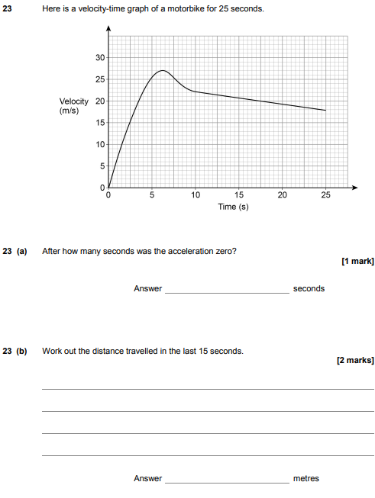

AQA GSCE – Thursday 8 June 2017 – Paper 2 (Calculator) Higher Tier
29.
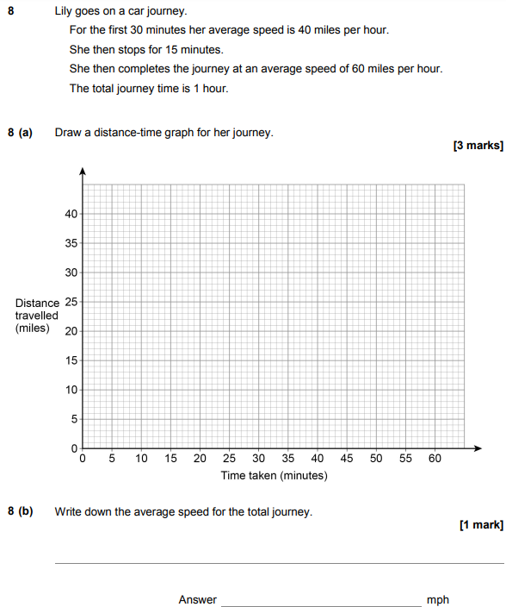

AQA GSCE – Tuesday 13 June 2017 – Paper 3 (Calculator) Higher Tier
30.
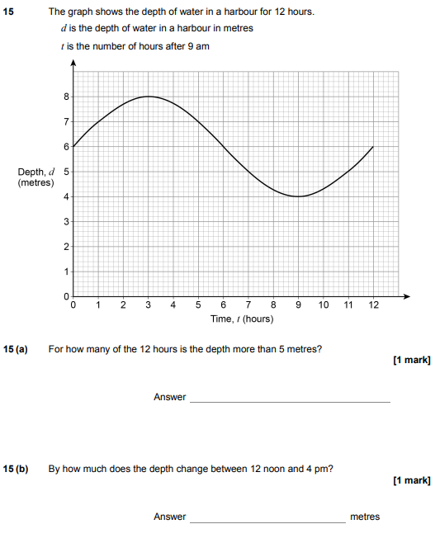

AQA GSCE – Tuesday 13 June 2017 – Paper 3 (Calculator) Higher Tier
31.
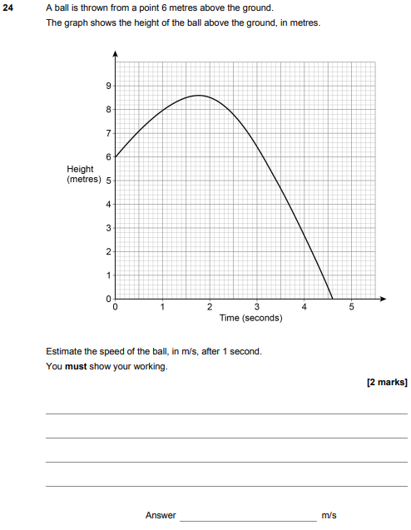

AQA GSCE – Sample Paper 1 (Non - Calculator) Higher Tier
32.
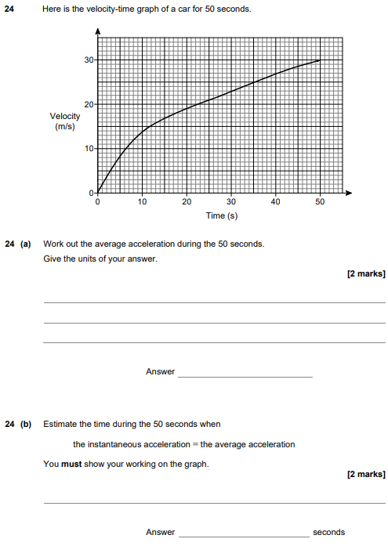

AQA GSCE – Sample Paper 3 (Calculator) Higher Tier
33.
